

SOCIAL AND PROFESSIONAL ISSUES FINAL EXAM

Group Members:
Gumatay, Luke July
Panes, Mark John
Valenzuela, Robert Kenneth
Technology’s Role in Democracy, Society, and Responsible Innovation
Technology plays a powerful role in shaping democracy and society. In today’s digital age, technological platforms allow people to access information quickly, participate in public discussions, and hold institutions accountable. Social media, online news platforms, and digital communication tools make it easier for citizens to express their opinions and engage in democratic processes. Technology also improves transparency through systems such as e-governance platforms, which allow governments to deliver services more efficiently and openly to the public.
Beyond democracy, technology contributes greatly to society by increasing access to education, communication, and economic opportunities. Digital tools allow people from different backgrounds to collaborate, learn, and share knowledge regardless of geographical barriers. Innovations such as cloud computing, artificial intelligence, and digital platforms have transformed industries and improved everyday life. When used responsibly, technology has the power to promote inclusivity, empower communities, and support social development.
However, technological innovation also brings risks when it is used irresponsibly. The spread of misinformation and disinformation online can manipulate public opinion and influence elections. Privacy violations, data breaches, and unethical use of personal information threaten the trust that society places in digital systems. Additionally, the digital divide continues to create inequality, where some communities lack access to reliable technology and internet connectivity. These challenges remind us that innovation without ethical responsibility can harm individuals, institutions, and democratic values.
Because of these challenges, IT professionals have an important responsibility in ensuring that technology is developed and used ethically. Technology is not just about innovation—it is also about responsibility. IT professionals must design systems with integrity, transparency, and respect for human rights. They must prioritize privacy protection, implement strong security measures, and ensure that technologies such as artificial intelligence are developed responsibly and fairly.
Building an ethical culture in technology organizations is essential. An ethical workplace promotes clear values, accountability, and psychological safety, allowing individuals to speak up and make responsible decisions without fear. Through proper ethics training, open communication, and continuous evaluation, organizations can reduce harm and create technology that truly benefits society.
As future IT leaders and professionals, we recognize that we play a vital role in shaping the future of technology. We must uphold ethical standards, advocate for responsible innovation, and contribute to building systems that prioritize people over profit. Culture is shaped by choices, choose to build responsibly.
As future IT professionals, we commit to responsible innovation that empowers society, protects democratic values, and ensures technology is used for the good of all.

POSTER
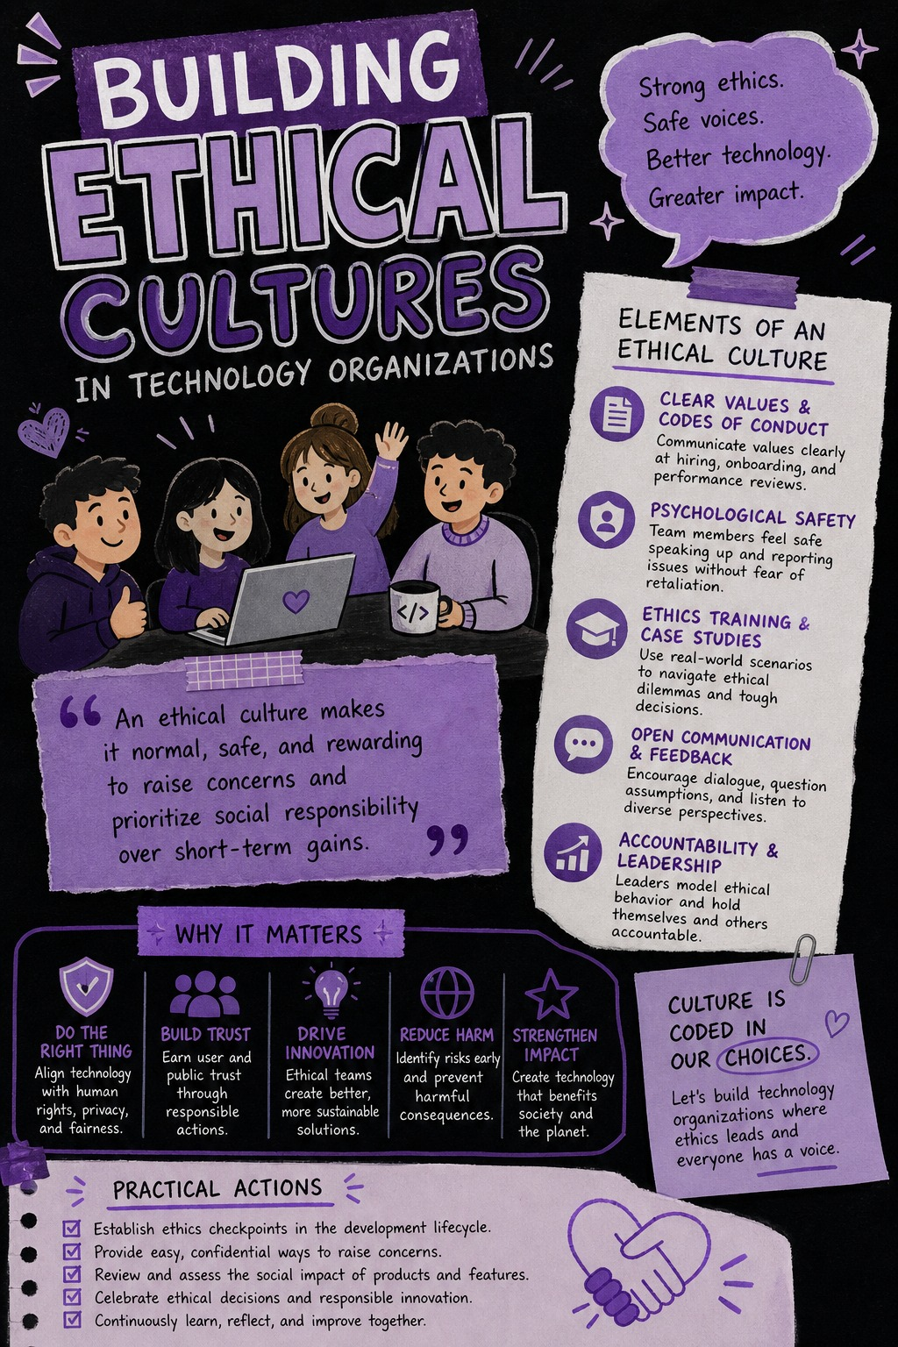

FACEBOOK POST
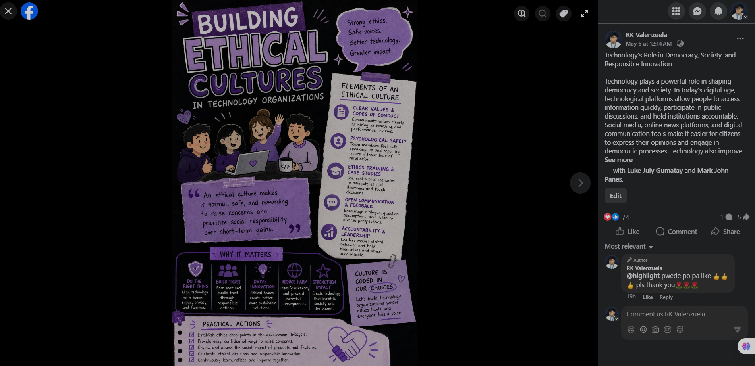
FACEBOOK POST LINK: https://www.facebook.com/share/p/1BG5CR83SV/

